Prelab

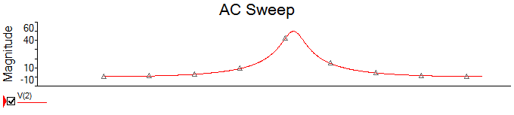

V=49.93

Figure 2

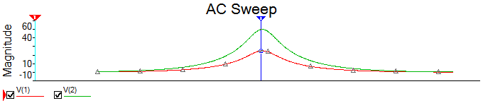

X = 34.35 Y = 24.92

$$XLp=\frac{Rl^{2}+Xl^{2}}{Xl}=\frac{{\left(50*628.32\right)}^{2}+{\left(628.32\right)}^{3}}{{\left(628.32\right)}^{2}}=50.63$$

Figure 3

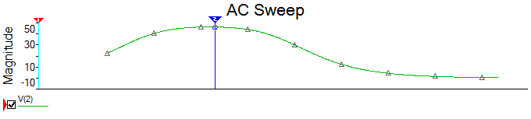

Y=46.32 V

$$lp=\frac{Xlp}{2pif}=\frac{50.63}{2pi*1000}=8.06mH$$

$$Rp=\frac{50*\left(628.32\right)+{\left(628.32\right)}^{3}}{628.32*50}=636.22ohms$$